User manual
Qi2 Ultrathin MagSafe Power bank 10000mAh
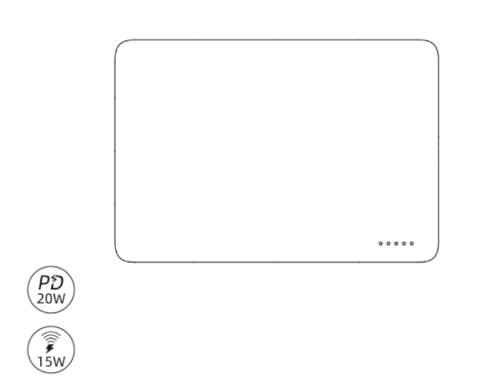

Thank you for purchasing our product. In order to give you a better experience, please carefully read and strictly follow the instructions and precautions before use and keep the instructions guidelines for reference.

Status Indicator Light

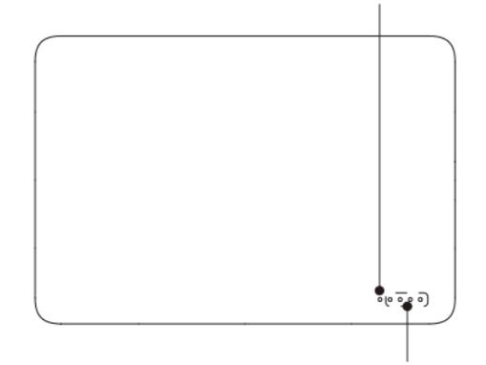

Battery Indicator Light

Magnet inside

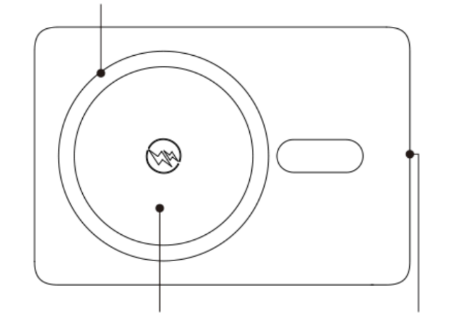
Wireless Charging Area Input/Output Interface

Instructions for Use

Charge the Magnetic Power Bank
1.Use USB-C charging cable, insert the cable into the USB-C port of the magnetic power bank, and connect the other end of the cable to the charger or computer. It is recommended to use a fast-charging charger with a power of 18W and above. The indicator light is always green during fast charging, and it is off during normal charging.
2. When charging the magnetic power bank, the battery indicator light flashes, and the 4 indicator lights are always on when fully charged.
3. After charging, unplug the charging cable in time.

Charge your phone or digital device via the USB-C output port of the magnetic power bank
- Use a suitable charging cable, connect one end of the cable to the USB-C port of the magnetic power bank, and connect the other end of the cable to your phone or digital device that needs to be charged, and then start charging.
- After charging, unplug the charging cable in time.

Charge your phone or digital device via the wireless charging of the magnetic power bank
- Place your phone or digital device that support wireless charging in the wireless charging sensing area of the magnetic power bank to automatically wake up wireless charging to charge your device. Some digital devices that cannot automatically wake up wireless charging, you can press the power
button on the left side to turn on and then charge for them.
- The wireless charging sensing area of the magnetic power bank is equipped with a powerful magnet. Smartphones that support magnetic charging can be used for adsorption, making charging more convenient. Please refer to the smartphone user manual for specific supported models.
- When using the power bank to wirelessly charge your phone, the surface of the battery may be slightly heated and it is considered normal until the temperature exceeds 45℃. Please do not worry. If it exceeds 45℃, please stop using immediately and contact us.

Function Description of Magnetic Power Bank Button
- Short press the power button to turn on the magnetic battery, and the current power level of the magnetic power bank will be displayed. For specific battery indication, please see the power display in the figure below.
- Press the power button continuously for 2 seconds to turn off the battery display and shut down.
- If the power bank is not used within 33 seconds, it will automatically shut down.

Power Display:
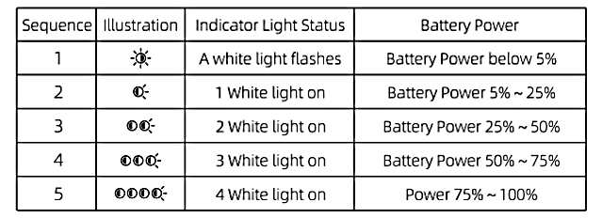

Charging Status Display:
Sequence | First Light Display Status | Status Description
1 | Light off | USB-C port for normal charging
2 | Green light on | USB-C port for fast charging
3 | Blue light on | Wireless charging normal output
4 | Blue light flashes | Wireless charging is abnormally output

Safety Precautions

- For Proper Use

Please follow the instructions in this User Guide to use this product properly.

- Repair Services

Do not disassemble this product. In order to avoid safety accidents, only authorized personnel are allowed to repair this product.

- Charging Instructions

1)This product can only be charged with a charger that meets its charging parameters.
2)If the status indicator light does not work property during charging because this product has not been used for a long period of time, please charge it for 30 minutes for observation.

Warnings:

- Damages caused by using a charger with unfitting parameters for charging is not covered by the warranty, and it may lead to other hazards.
2. If battery temperature of this product reaches 50℃ during charging and reaches 60℃ during discharge, the NTC protection function will be triggered, and the charging power will drop till the temperature goes down, then the charging power will go up again. The recommended ambient temperature for charging is 0~30℃.

Specifications
Product Name: Qi2 Ultrathin MagSafe Power bank
Model: DV400009
Capacity: 10000mAh(38.5 Wh)
Rated Capacity: 5800 mAh
Weight: 190g
USB-C Input: 5V=3A, 9V=2A, 12V=1.5A
UsB-C Output: 5V=3A, 9V=2,22A, 12V=1.67A
Wireless Output: 5W|7.5W|10W|15W Max
Material:Aluminum Alloy + ABS

WARNING

- Do not dismantle or modify the product;
2. Do not store the product in wet conditions;
3. Do not charge or use the product near heat sources;
4. Do not let water or any other liquid flow into the inside part of the product's interface. This would cause damages to the product;
5. Avoid direct sunlight;
6. Keep away from children and pets to prevent accidental ingestion;
7. Stop using the product if overheating occurs;
8. Please use a dry soft cloth to wipe, avoid using harsh chemicals or strong detergents.



